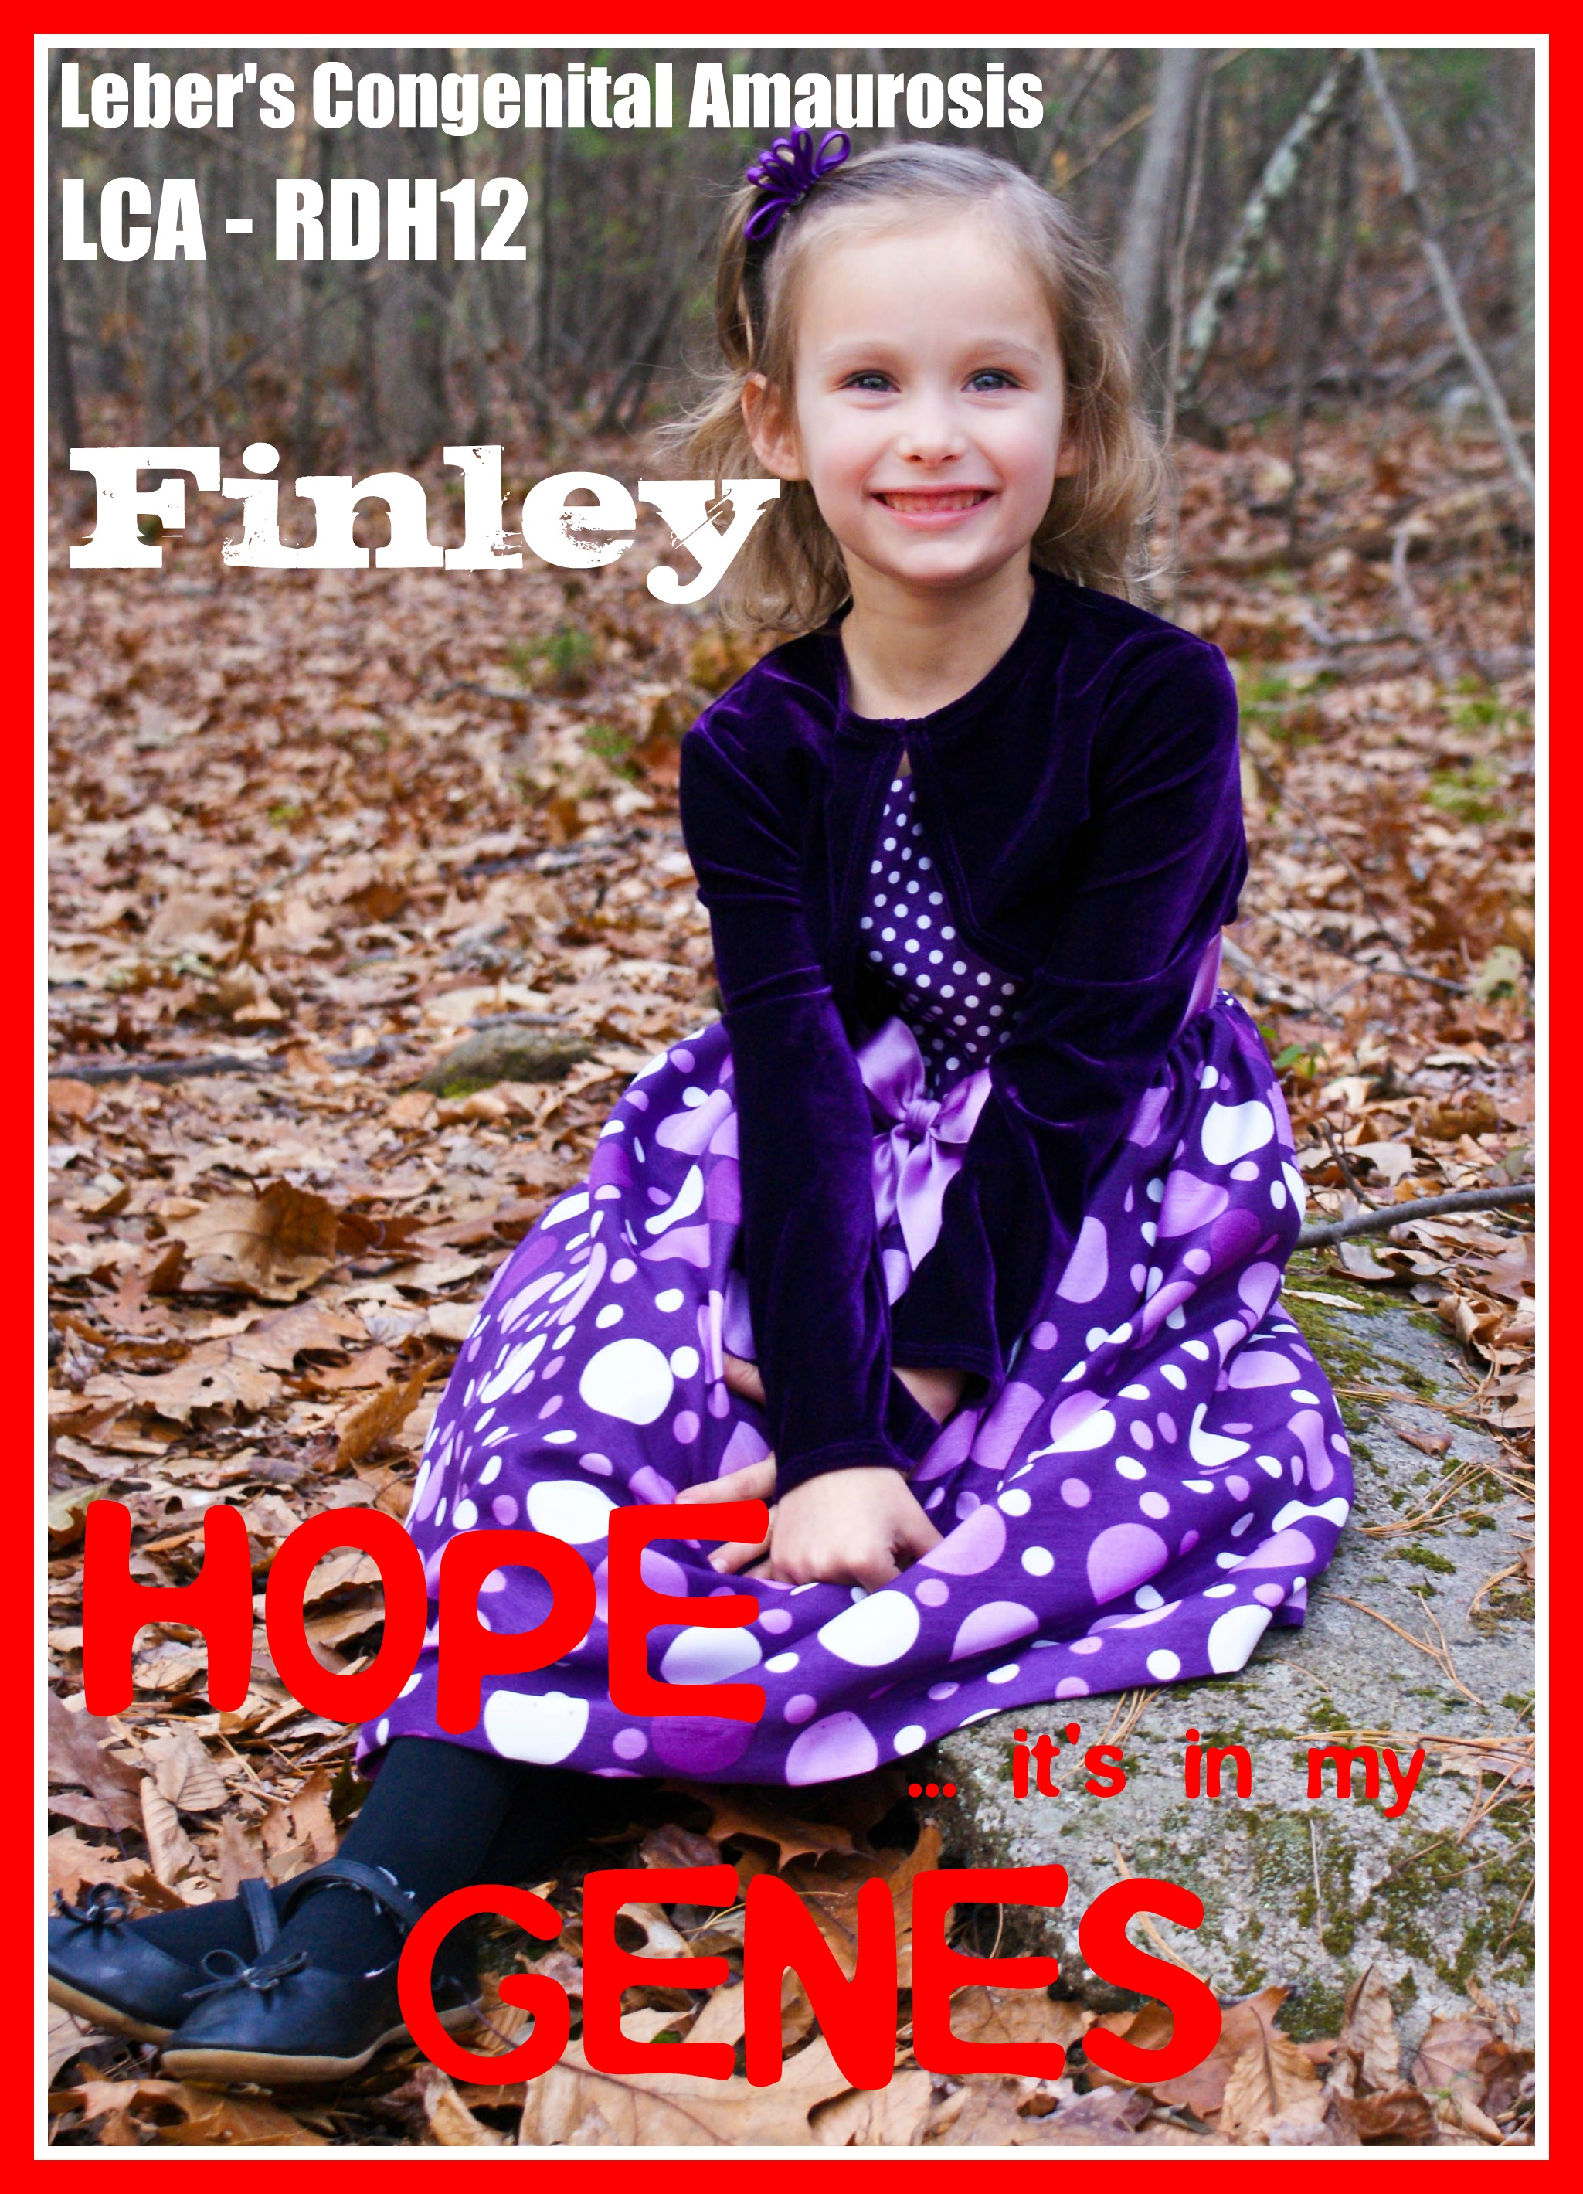
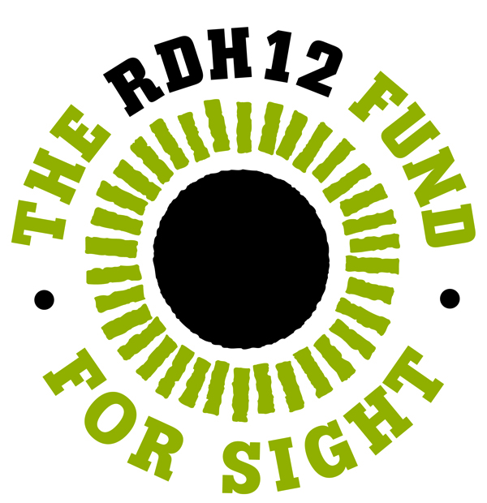
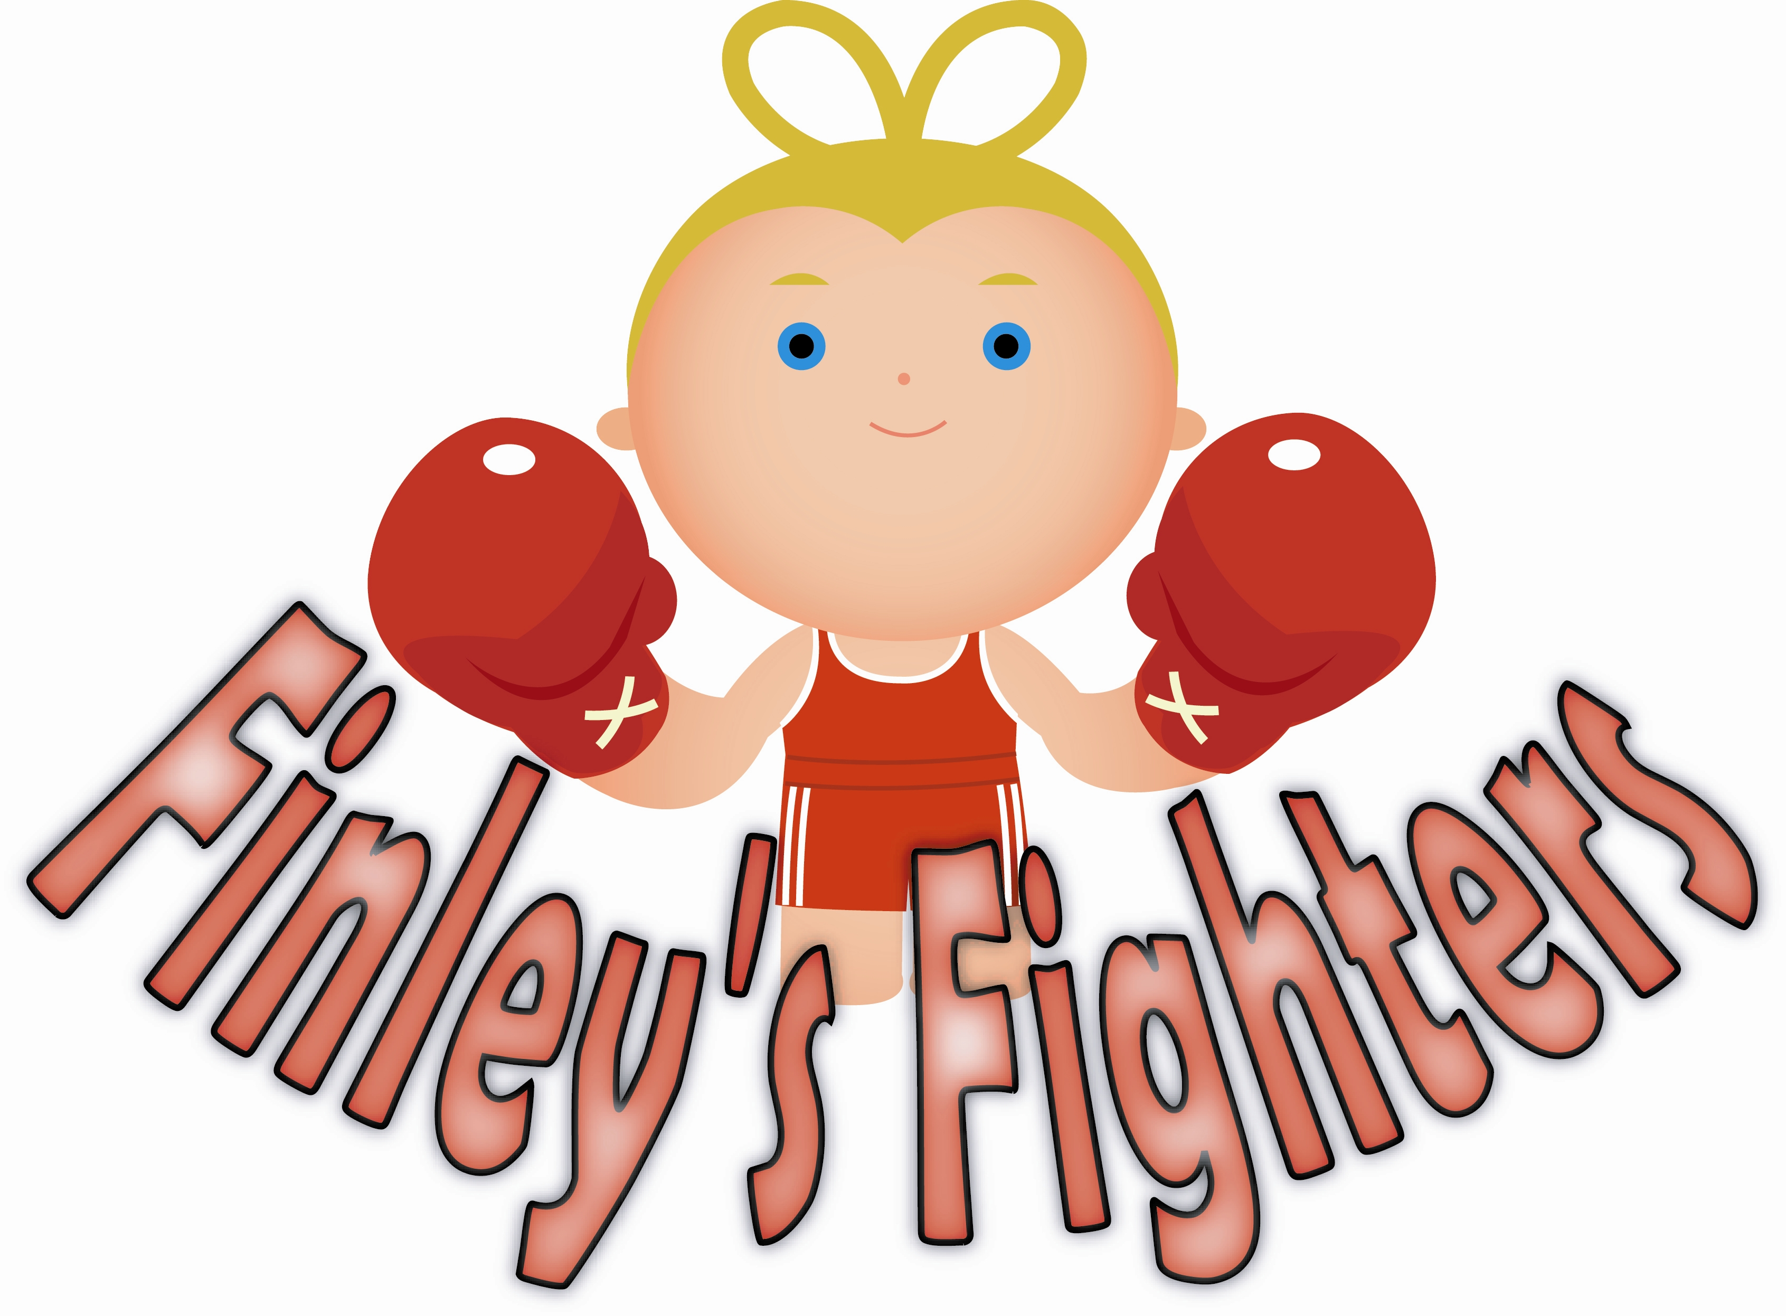
Finley's Fighters Race for Sight
Date of event: August 16, 2014

Yough River Trail
369 North 3rd Street, Connellsville, PA 15425

Races: 10K run, 5K walk/run, ½ mile fun run
Times
8am – registration begins
8:50 am – ½ mile fun run
9:15am – 10K run and activities begin
9:20 am – 5K run and walk begin
10:45 am – lunch starts
12:30pm – event officially ends
Event is RAIN or SHINE. .

Fees: Pre-register: (up to 1 week before the event) $20/person or $55/family (3 people or more) – participation in the race (any of them), a shirt, goody bag, personalized braille bookmark, bag check and food.
1 week prior to the event and Day of Event: $25/person or $70/family (3 people or more) – participation in the race (any of them), a shirt, goody bag, bag check and food.

All Kids under 18 get a hand carved medal no matter what race they run!
Children under 3 are FREE (for food and registration)

Activities: bounce house, basket raffle, lunch, hair feathers, face painting, music, and more!

To get more information on the race, please visit .
You can print out a form and mail it in or register online with your credit card!

Finley Pletcher is the 8 year old daughter of Jennifer and Mathew Pletcher and the granddaughter of Ted and Phyllis Kovall of Connellsville and Ben and Sally Pletcher of Indian Head. Finley has been diagnosed with a rare eye condition called Lebers Congenital Amaurosis RDH12. This condition will cause her to go completely blind by the time she is a teenager. Currently there is no cure. Her family raises money for research that is being conducted to find a cure and keep her from going blind. All proceeds from this event will be for research to find a cure for Lebers Congenital Amaurosis RDH12.
The name of our official non-profit is the RDH12 Fund for Sight named after Finley's diagnosis. RDH12 Fund for Sight is a 501(c)3 registered non-profit. All donations are tax deductible. All monies donated to the RDH12 Fund for Sight will be sued to fund RDH12 research.

Registration Form
Please fill out completely and return it along with your payment (checks made payable to RDH12 Fund for Sight) to:
Phyllis Kovall
1231 Sycamore Street
Connellsville, PA 15425
ONE REGISTRATION FORM PER IMMEDIATE FAMILY. PLEASE
UNDERSTAND THAT YOU CAN ONLY SIGN UP ON THIS FORM
AS A FAMILY IF CHILDREN ARE LIVING WITH YOU AND ARE
UNDER THE AGE OF 18. IF CHILD IS OVER 18, THEY NEED
THEIR OWN FORM AND SEPARATE REGISTRATION.
Please make sure you put EVERYONE’s NAME and AGE on this form.
Also please sign the bottom of this form and mail in with your payment.
Name(s):__________________________________ AGE(s):_______
Address:__________________________________________________
City:_________________________State__________Zip__________
Email: ______________________________

T-shirt size (for each person):
Child: 2/4(XS)____6/8(S)_____10/12(M)____14/16(L)______

Adult: S_____M______L______XL______XXL______XXXL (please add $5 to your reg. for this size)______

Event (please write who is running/walking what):
10K run____________________________________________________________
5K walk or run_______________________________________________________
1/2 mile fun run______________________________________________________
Spirit Runner________________________________________________________
Race only (no shirt/lunch)____________________________________ ($10/person)
½ mile fun run race only (no shirt/lunch)________________________ ($5/person)
Lunch Only_________________________________________________($5/person)
Children under 3________________________________________ (FREE, but no shirt)
Shirt only:_____________________________________________($10/person)
I am unable to attend, but I would like to make a donation:_________

If you want to purchase Basket Raffle Tickets ahead of time so that they
will be in your race packet when you arrive – you can do so on this form.
YOU DO NOT HAVE TO. YOU CAN STILL PURCHASE TICKETS
AT THE EVENT.
Basket Raffle Tickets ($2/ticket, $10/6 tickets, $20/25 tickets)_______
Basket Raffle #2 Tickets ($5/ ticket, $40/10 tickets)_______
In consideration of my entry being accepted, I hereby for myself, my heirs, executors, successors, and assigns, wave, release, and discharge any and all right for damage or liability of any kind relating to or arising out of my participation in this event, even though that liability may arise out of negligence or carelessness on the part of the entities or persons named in this waiver and release. I attest that I am physically fit to participate, my condition has been verified by a licensed medical doctor and I assume entry into this event at my own risk. I have read the above conditions and accept them and understand that I am entering at my own risk. Date_____________________________ Signature:________________________ (Parents must sign for children under 18)

